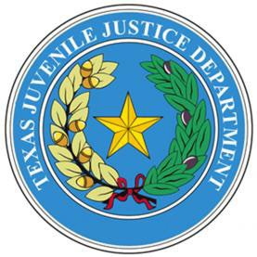

H. Lynn Hadnot, Chairman  Chief, Dallas County | Jason P. Davis, Deputy Chair  Chief, Kerr County | Ross Worley,  Chief, Smith County | Honorable Judge Mark Allen Jasper County Judge
Lindsey Van Buskirk CPS Director of Field | Troy Navarrette Chief, Potter County | Maryanne Denner,  Chief, Hidalgo County | Honorable Judge Foy O’Brien, Dawson County Judge
Monica Schniers Chief, Tom Green County | Ed Cockrell  Chief, Jefferson County | Ashley Kintzer  TJJD, Manager of Regionalization | Honorable Judge Teana V. Watson Fort Bend County Court #5
Shandra Carter  TJJD Executive Director | Courtney Harvey  HHSC Mental Health Statewide Coordinator & Associate Commissioner

Advisory Council on Juvenile Services Meeting Friday, August 7, 2026 @ 10:00 AM
Virtual Meeting: TEAMS Meeting ID: 262 328 252 344 202
Passcode: c6y2JC9Q
Download Teams | Join on the web

Meeting Agenda

- Call to Order /Council Rollcall:
Lynn Hadnot, Chair

- Finance Committee Discussion and Recommendation on Funding Cut:
Emily Anderson – Action Item

- Next Meeting of Council:
Date, Time, Location Discussion

- Public Comment (must email boardmaterials@tjjd.texas.gov by 5:00 p.m. on August 6, 2026, to register for public comment)

- Adjourn

As deemed appropriate, Advisory Council may take agenda items and/or public comment out of agenda order.

