How to Enter an Regional Program (pre-funded bed) Discharge in Fluxx
Youth Discharge Access:
Find the Approved Grants section on the gray dashboard to the left of your screen. Select Approved – with PID, then select the placement card you’re needing to discharge. The Edit function should appear at the right of the screen, and then you’ll need to submit that change by clicking the “Discharge details updated”. Please reach out if you have further issues with discharge access.

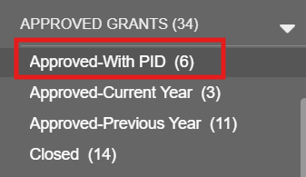

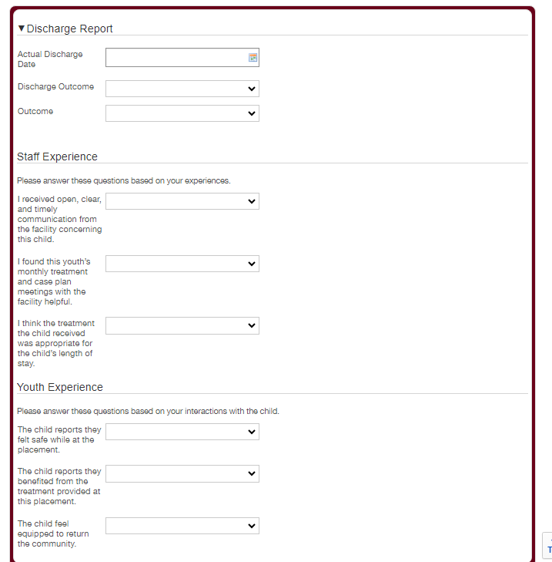

- Enter the actual discharge date
- Enter the Discharge Outcome
- Complete the Staff Experience survey regarding the placement
- Complete the Youth Experience survey regarding the placement

Once Completed select Save and Close

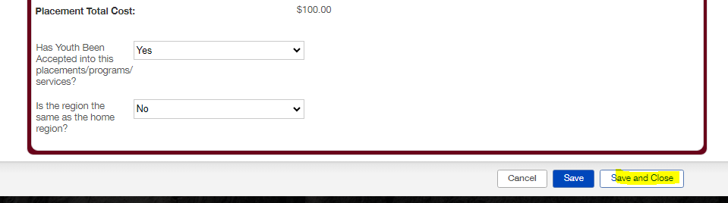

Select Discharge Details Updated to Submit
