How to Submit Special Request Amendments in Fluxx for Departments
Special Requests are amendments to the grant that allow departments to request changes to the grant or request specific items as outlined in the TJJD Grants contract. Examples are: purchases of more than $10,000, changes to the scope of a program, out of state training (regardless of dollar amount), etc. Requirements can change from year to year; therefore, departments should consult their contract or contact TJJD Fiscal Staff if they are unsure. Please note that special requests are NOT budget adjustments.

To submit a special request in Fluxx:
- Navigate to the GRANTS section of the dashboard.
- Select the card for the grant the Special Request is to be applied to. The background color of the card will turn green and the grant information will populate on the right side of the screen.
- Click the Request Amendment button in the upper right corner of the screen.
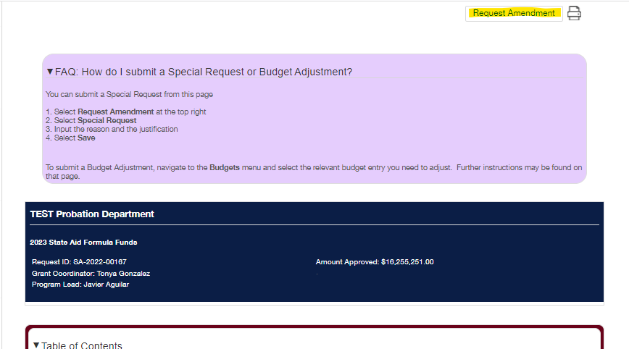
- Click Special Request in the popup.
- Special Requests
  - "What type of amendment are you requesting?" Select an option from the drop down below.
    - Purchase of >$10,000 - This is selected when a department wants to spend more than $10,000 out of the grant, typically for a large equipment purchase such as a new vehicle, new computers, etc. A quote is required and will be submitted in the Documents section.
    - Program or Application - This is selected when a department wants to make a change to the scope of a grant or application. For example: A department receives a grant for a specific program, however, something happens during the year and the department realizes they need to pivot and make some changes to the program to make it more effective. A Special Request needs to be submitted to explain the reason for the desired change.
    - Other - This is selected, most often, for out of state travel but could apply to any request that is not covered by the previous options. Documentation may need to be provided, depending on the request, which will be submitted in the Documents section.

  - Justification - Type in the text box.
    - Departments need to provide a detailed reasoning for their request, but should be concise and clear.
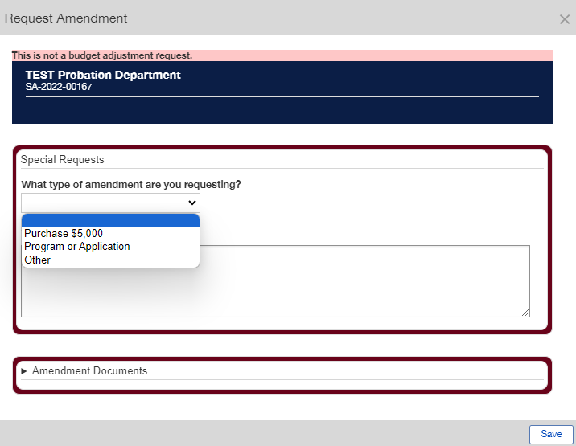
  - Amendment Documents - Upload Supporting Documents
    - This section allows departments to upload any related documentation needed for their requests such as price quotes, agendas for out of state trainings, invoices, bills, salary documentation, etc.
      - To upload a document, click on Amendment Documents to open the section.
      - Click the green circle with a plus sign in it on the right.
      - Click Add Files or drag and drop files into the box that says "Drag files here."
      - Once all files are selected, click Start upload.
        - Unnecessary files can be deleted by clicking the red circle with a line through it on the right of the file.
      - The status on the bottom left of the box will change to Upload Complete! once all files have been uploaded successfully and the red circle will turn to a green circle with a check mark.
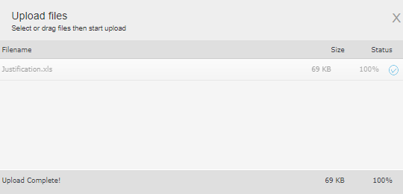
      - Click the X on the top right to close the Upload Files box.
        - Documents can be added to, deleted, or viewed by selecting the appropriate icon on the right side of the document name in the Documents box.
  - Once all information has been added and all documents uploaded, if needed, click the Save button. This will submit the Special Request.
  - An Amendment will be created and will show up under the Submitted status in the Amendments section in the dashboard. Here the Special Request amendment can be viewed or printed but cannot be edited.
    - If a department needs to make a correction to their Special Request, please email the Fiscal Team and the amendment will be sent back to the Edits Requested status. The department will then be able to make the necessary changes and resubmit.
  - Once a Special Request is submitted, it will be reviewed by the Fiscal Team and the departments Regional before moving on for final approval. Once a decision is made, the submitter will receive an email to indicate whether it was approved or not.

