

Texas Juvenile Probation Commission
INTER-COUNTY TRANSFER OF PROBATION SUPERVISION
Overview and Implementation Recommendations
September 1, 2007

I. OVERVIEW

During the 80th Legislative Session, House Bill 2884 contained amendments to clarify some of the practical and procedural aspects of interim and permanent supervision. This handout is an update of the Implementation Recommendations first released in 2005 and incorporates the legislative changes identified by juvenile justice personnel responsible for handling supervision transfer cases. The amendments to Sections 51.072 – 51.074 of the Texas Family Code (TFC) will become effective on September 1, 2007 and apply to transfers occurring on or after the effective date. The following information as well as related sample documents, forms and pleadings have been provided by the Texas Juvenile Probation Commission (Commission) as an educational service to assist local juvenile probation departments, prosecutors and judges in implementing and establishing local policies and procedures that address the new law regarding inter-country transfers of probation supervision. All sample documents, forms and pleadings are available for download at the Commission’s website at www.tjpc.state.tx.us. It is recommended that all sample documents, forms and pleadings be reviewed by each local juvenile court prosecutor for legal sufficiency and adapted for your county’s particular situation or drafting preferences.

II. DEFINITIONS

- Child Transfer Packet: This packet refers to the 18 categories of information mandated in Texas Family Code Section 51.072(f) that are required to be forwarded by the Sending County to the Receiving County upon acceptance of interim supervision of a child.
- Inter-County Transfer Officer: The person designated by the chief administrative officer (i.e., chief juvenile probation officer) to act as the contact person for all matters involving the transfer of juvenile probation supervision between counties.
- Receiving County: Receiving County refers to the county in which a child on probation has moved or intends to move. [TFC 51.072 (a)(1) and 51.073(a)(1)].
- Residence: When used in reference to the residence of a child for purposes of inter-county transfer of probation supervision, refers to the county where the child intends to move or has moved and intends to remain for at least 60 days. [TFC 51.072(b)].
- Eligible Person: Parent, guardian, custodian or other responsible person with whom the child resides or will reside as each are defined in Title III of the Family Code. [TFC 51.02; 61.001(2)].
- Sending County: Sending County refers to the county that originally placed the child on probation or assumed permanent supervision of the child under an inter-county transfer of probation. [TFC 51.072 (a)(2) and 51.073(a)(2)].

III. DESIGNATION OF AN INTER-COUNTY TRANSFER OFFICER

The Biennium State Financial Assistance Contract between local juvenile boards and the Commission requires each juvenile board to designate and provide contact information for an Inter-County Transfer Officer (ICT Officer) to serve as the primary contact for all matters involving inter-county transfer of probation supervision in compliance with TFC Section 51.072 (d). The ICT Officer may be the chief juvenile probation officer. As contemplated by the statute, the officer will serve as the source and/or recipient of any information (e.g., court papers, social and psychological reports, incident reports, juvenile identifying information, case plans, etc.) that must be exchanged between the sending and receiving counties. The ICT Officer for each county can be located in the Commission’s web-based Juvenile Probation Directory that contains key personnel contact information for use by juvenile justice personnel around the state. This information can be accessed at www.tjpc.state.tx.us. See the following directions and examples.
Step 1
Access the Commission’s website at www.tjpc.state.tx.us and select the tab About TJPC.
A dropdown menu will appear; select the Juvenile Probation Directory link.

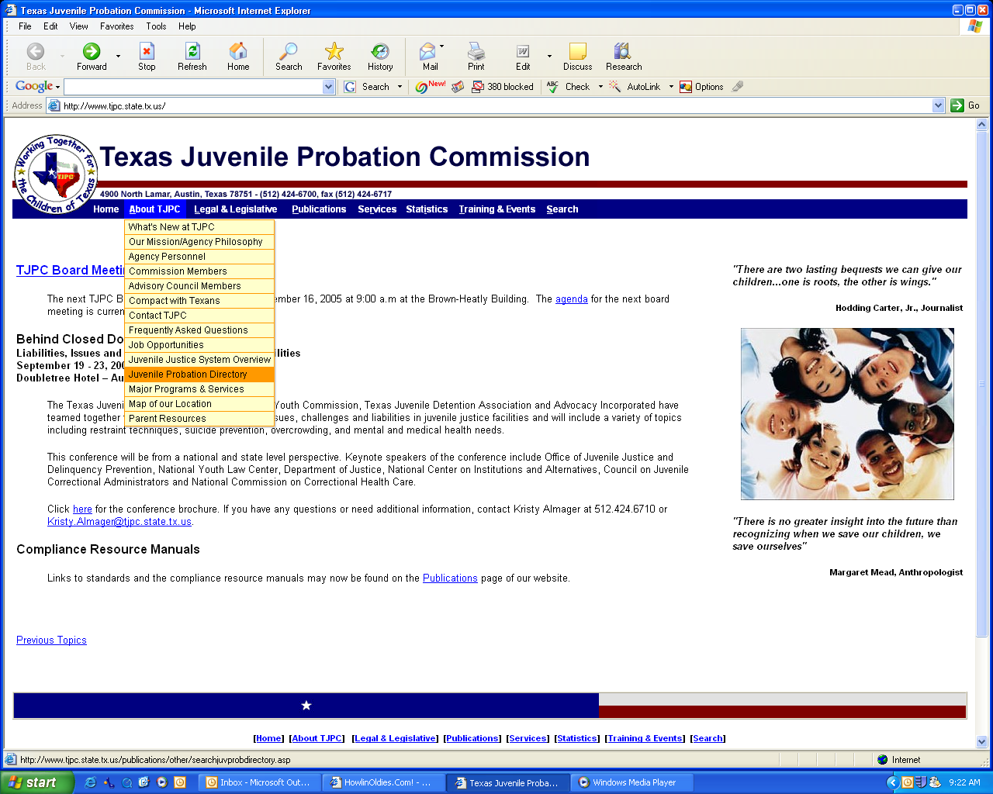

Step 2
At the Texas Juvenile Probation Directory page, the position of Inter-County Transfer Officer
may be searched by a specific county or statewide. In the example below, the search is for Harris County information.

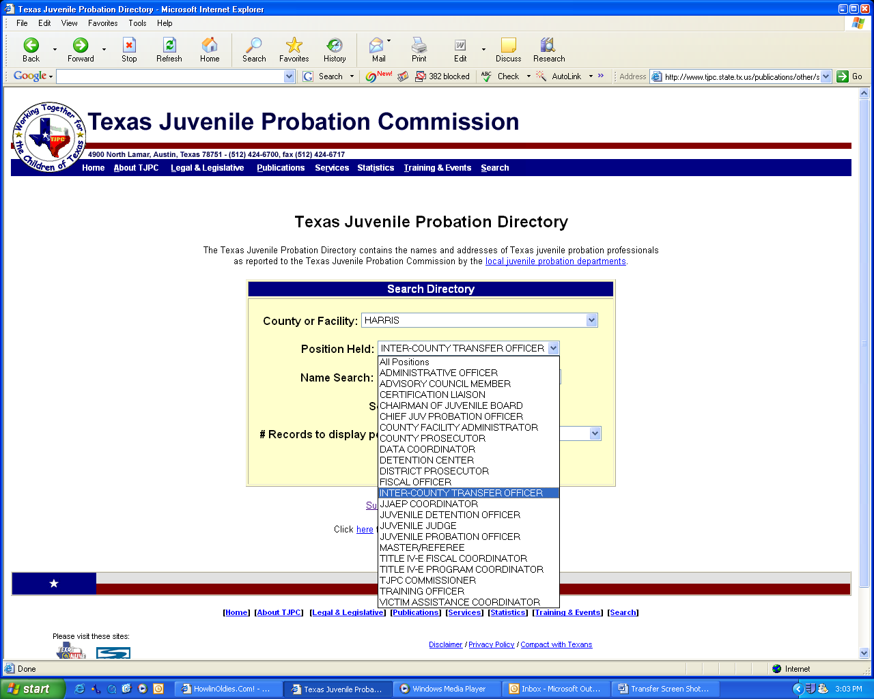

Step 3
As shown here, the search produced the contact information for the
Inter-County Transfer Officer in Harris County.

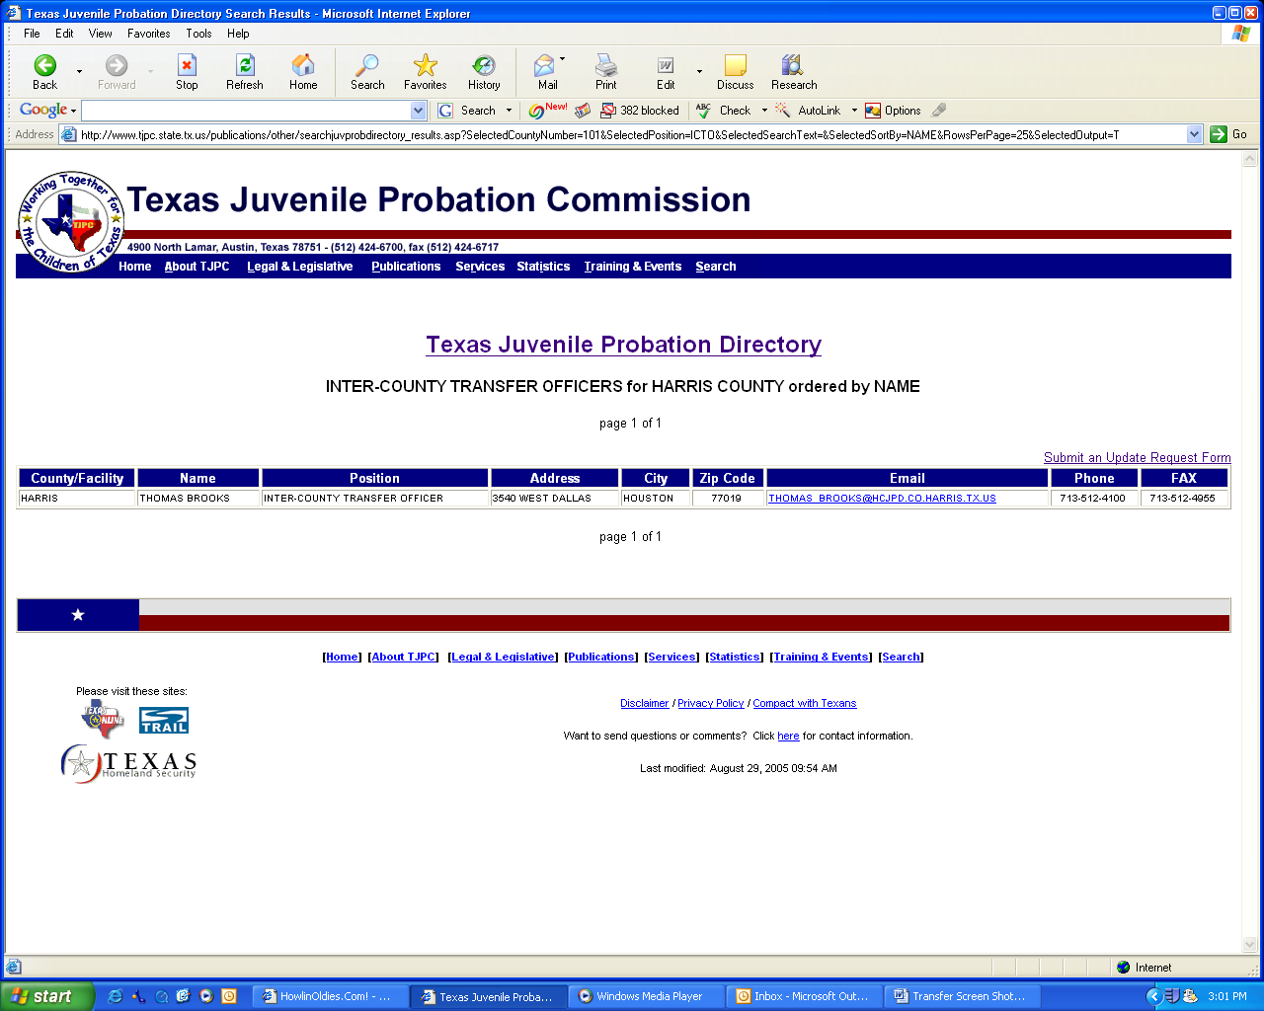

Practice Pointer: Each juvenile probation department must maintain current information on its ICT Officer and must advise the Commission of any address and/or personnel changes regarding the designation of the ICT Officer in writing within ten (10) calendar days of the effective date of the change. This may be done using the website update screen shown below. The following information will be required:

ICT OFFICER NAME: Joseph A. Probation
COUNTY TITLE: Inter-County Transfer Officer
MAILING ADDRESS: 4900 North Austin, Anytown, Texas 77777
TELEPHONE: 000-000-0000
FAX: 000-000-0000
EMAIL: Name.Name@any.email.provider.com

Updating ICT Officer Information
Input any new required information by accessing the Update Request Form page.

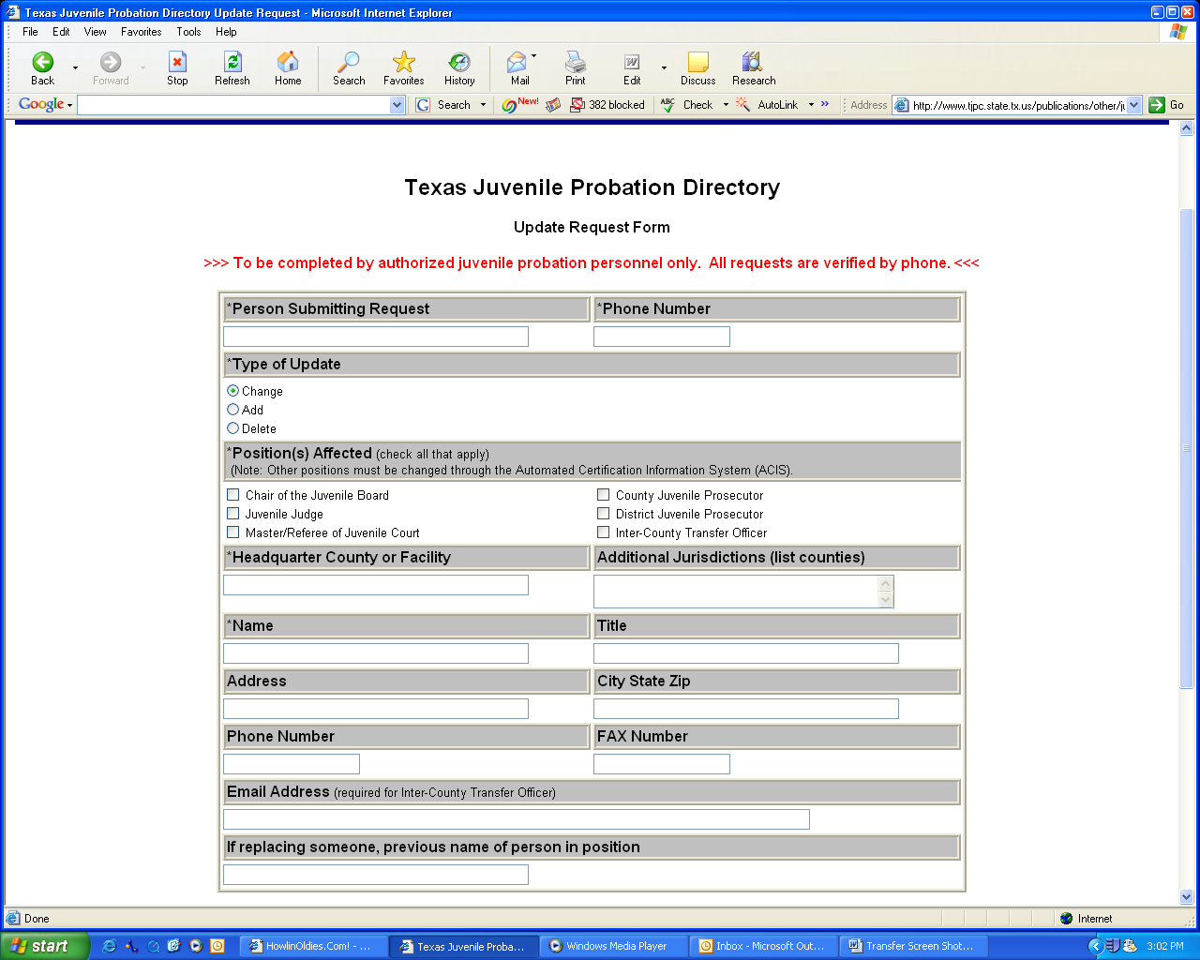

IV. INTERIM SUPERVISION

- Triggering Event: Child Moves or Intends to Move. The provisions regarding interim supervision must be activated when a child on probation has moved or intends to move from one county to another and intends to remain in that county for at least 60 days. [TFC 51.072(b)]. The county that placed the child on probation is the Sending County and the county to which the child moves or intends to move is the Receiving County.

Practice Pointer for Sending County:

    - The ICT Officer in the Sending County should have reasonable information to establish that the child on probation will reside in the new county. For example, when the supervising probation officer has received information from the child and/or a eligible person that the child is moving or intends to move to a new county as a result of a change of circumstances such as a custody provision of a divorce decree or a change of employment, sufficient identifying information should be collected regarding the person with whom the child will reside and the address of relocation. Additionally, information as to when the child will reside in the Receiving County is important. This information should promptly be forwarded by the child’s probation officer to the ICT Officer for the Sending County to assist that person in completing the Child and Family Identifying Information form. [TJPC-ICT-04-06] which is necessary to initiate a request for interim supervision.

    - Multi-county jurisdictions and judicial districts are not required to initiate a request for interim supervision from a county served by the same probation department. [TFC 51.072(b)].

    - Note: Once supervision becomes permanent in the Receiving County, the Receiving County then becomes the Sending County if the child were to move again.

- Initiating a Request for Interim Supervision

- Notification by Sending County. TFC Section 51.072(d) requires that the juvenile probation department of the Sending County request that the Receiving County provide interim supervision of the child. The request should be initiated by sending an electronic message to the ICT Officer in the Receiving County.
SAMPLE FORMS

    - Request to Initiate Interim Supervision [TJPC-ICT-03-06]. This sample email provides language that the Sending County may use to initiate a request for interim supervision to the Receiving County.

    - Child and Family Identifying Information [TJPC-ICT-04-06]. This sample form may be used to provide identifying information required to accompany an initial request for interim supervision. The ICT Officer in the Sending County should fill out the form in its entirety and email the request for interim supervision and the completed form as an email attachment to the designated ICT Officer in the Receiving County.

Practice Pointers for Sending County:

    - Prior to transmitting the request, the Sending County should:
    - Review its records to verify that the child is not residing in the Receiving County as a result of a residential placement that it arranged or in a Department of Family and Protective Services (DFPS) foster care placement.
    - Verify the date the child began or will begin residing in the Receiving County.
Note: The ICT Officers must establish an official start date within three (3) business days of the time that all documents have been received and accepted. When practical, it is recommended that the third (3rd) business day start date should coincide with the day the Receiving County has its initial face-to-face meeting with the child. [TFC 51.072(f-1).
    - The Sending County ICT Officer should, if available, select an email program option that would allow for receipt confirmation from the Receiving County ICT Officer.
    - Verify e-mail addresses. The ICT Officer should take precautions to ensure that confidential information is not being disseminated to anyone other than the intended recipient.
    - Because e-mail addresses frequently change, place a courtesy call to the ICT Officer in the Receiving County to advise that the e-mail was sent.
    - Attach a completed Child and Family Identifying Information form.
    - Document the request for interim supervision in the child’s case file.
    - Anticipate a prompt reply from Receiving County. If no reply has been received within two business days, follow up with a telephone call.

- Receiving County Duties after Notification. As a matter of law, the Receiving County is required to promptly accept interim supervision of the child so long as the child has moved or intends to move to the Receiving County and will remain there for at least 60 days. TFC Section 51.072(c) sets forth two circumstances in which the Receiving County can refuse interim supervision of a child residing in its county. Specifically, interim supervision may be refused when the child is in the Receiving County as a result of a residential placement arranged by the Sending County or when the child is in a DFPS foster care placement in the Receiving County. Under TFC Section 51.072(b), multi-county jurisdictions and judicial districts are not required to initiate a request for interim supervision from a county served by the same probation department.

SAMPLE FORMS

    - Acceptance of Request for Interim Supervision [TJPC-ICT-05-06]. This sample email provides language that the Receiving County may use to accept and acknowledge a request for interim supervision.
    - Refusal of Request for Interim Supervision [TJPC-ICT-06-06]. This sample email provides language that the Receiving County may use to refuse a request for interim supervision for one of the statutory reasons.

Practice Pointers for Receiving County:

    - Send a REPLY email immediately accepting or refusing interim supervision.
    - If the request is refused, affirmatively state in the email reply the statutory reason for the refusal.
    - Verify the Receiving County’s contact information.
    - As a courtesy, attach to the e-mail a blank Child Transfer Packet Checklist for the convenience of the Sending County.
    - Request that all supporting documentation be forwarded in one complete packet.
    - Document your receipt and reply to the request for interim supervision in the child’s case file.
    - Anticipate receiving the Child Transfer Packet with all applicable supporting documents required in TFC Section 51.072 (e) from the Sending County promptly but no later than ten (10) business days of acceptance of interim supervision. If not received promptly, place a follow-up telephone call.

- Sending County Duties Upon Acceptance by Receiving County. TFC Section 51.072(f) sets forth 18 categories of information that are normally a part of a child’s case file. The sample Child Transfer Packet Checklist tracks the supporting documentation required to facilitate an interim supervision transfer under TFC Sections 51.072 (e) and (f). The Sending County is required to forward all mandated and applicable documents which make up the Child Transfer Packet to the Receiving County immediately, but no later than ten (10) business days after the Receiving County has agreed to provide interim supervision.

SAMPLE FORM

    - Child Transfer Packet Checklist [TJPC-ICT-07-06]. This sample form is a checklist that details the supporting documentation required by statute to be sent by the Sending County to the Receiving County upon acceptance of interim supervision by the Receiving County. The sample Child Transfer Packet Checklist reorganizes the information listed in the statute into specific user-friendly categories. The statute mandates all of the listed documents with certain exceptions. Examples of exceptions include the use of terms such as “any”, “if available”, and “in possession of” in the actual statute. These terms appear to limit certain documents to information that may already be an existing part of the juvenile’s case file at the time of the request for interim supervision. All mandatory items are designated in bold letters on the Child Transfer Packet Checklist.

Practice Pointers for Sending County:

    - Immediately prepare the Child Transfer Packet by compiling all mandated and applicable pleadings, reports and other information from the child’s case file in order to comply with the requirements of TFC Section 51.072(f).
    - Timely send the Child Transfer Packet to the Receiving County with a copy of the completed checklist no later than ten (10) business days after acceptance of interim supervision.
    - Document the transmittal of the Child Transfer Packet in the child’s case file.
    - Consult promptly with the ICT Officer in Receiving County to establish, within three (3) business days, the date interim supervision will officially begin. [TFC 51.072(f-1)]. This date is critical in order to establish when jurisdiction transfers and permanent supervision begins.

- Receiving County Assumes Interim Supervision. TFC Section 51.072(g) requires the Receiving County to supervise the child under the original probation conditions imposed by the Sending County and provide services similar to those provided to a child on probation under the same conditions in the Receiving County. See also Section VII. Fees and Financial Responsibility for Services.

V. VIOLATIONS OF PROBATION AND MODIFICATIONS DURING INTERIM SUPERVISION

- Receiving County Modification Proceedings Upon Acceptance of Interim Supervision. When a child is initially placed on interim supervision, TFC Section 51.072(g) authorizes the juvenile probation department in the Receiving County to request a modification of probation except that financial conditions and the length of the probation term may not be modified. The Receiving County’s juvenile court may modify the Sending County’s probation order just as it would its own via a regular modification proceeding under TFC Section 54.05.

Practice Pointers for Receiving County:

    - File a Motion to Modify.
    - Receiving County’s juvenile court must designate a new cause number for identifying the modification proceedings in its county.
    - Receiving County’s juvenile court may grant a motion modifying probation conditions.
  - Exceptions: No Modification of
    - Financial Conditions, (i.e., fees, costs, restitution ordered by Sending County)
    - Length of Probation Term

Note: This (option) allows the Receiving County flexibility in providing probation services similar to those that would have been provided by the Sending County. Similarly, if the Receiving County has conditions different from the Sending County that it imposes on each child, this option allows the Receiving County to modify the child’s probation conditions to reflect the Receiving County’s practice.
- Modifications for Violations of Probation During Interim Supervision
- Issuance of a Directive to Apprehend and Detention. TFC Section 51.072(i) authorizes either the Sending or Receiving County to issue a directive to apprehend (DTA) or to detain a child in a certified detention center if it reasonably believes that the child violated an original condition of probation.

- Modification Options. TFC Section 51.072 (i)(1) authorizes the Receiving County to modify a child’s probation conditions or extend the probation term. Alternatively, TFC Section 51.072 (i)(2) authorizes the Receiving County to require the Sending County to resume direct supervision of the child.

- Incidents of Violation. TFC 51.072(j) requires the Receiving County’s juvenile probation department to provide the Sending County with supporting written documentation of the circumstances relating to the technical or offense violations of probation upon which the directive to resume is based. This documentation provides the Sending County with the probable cause to file a modification under Section 54.05 and substantiates the rationale for returning the case back to the Sending County.

- Child Moves to Third County. When a child moves to a third county, other than the Sending or Receiving County, prior to the expiration of interim supervision, TFC Section 51.072(m-1) allows the Receiving County to close out and send the case back to the Sending County by means of a Directive to Resume Supervision. It is important to remember that the Sending County actually retains jurisdiction over a child and is required to resume supervision or initiate a request for supervision in the child’s new county of residence, if appropriate. See Directive to Resume Supervision –alternate language. [TJPC-ICT-08-06].

SAMPLE FORM

    - Directive to Resume Supervision [TJPC-ICT-08-06]. This sample directive of the juvenile court should be used when a child violates a condition of probation under interim supervision and the Receiving County determines that it will not seek to revoke or modify the probation conditions but will require the Sending County to resume supervision of the child. The ICT Officer in the Receiving County should present the Directive to Resume Supervision to the juvenile court for signing and entry. The ICT Officer should prepare any available supporting documentation (e.g., offense report or technical violation documents, etc.) and forward a copy of the directive to the ICT Officer in the Sending County to advise that supervision of the child should be resumed. The directive requires that the Sending County arrange and be financially responsible for prompt transportation of the child back to the Sending County. In 2007, this form was updated with alternate language that can be used when a child on interim moves or violates the terms and conditions of deferred prosecution.

Practice Pointers for Receiving County:

    - File a Motion to Modify.
    - Modify the conditions of probation or extend the probation term.
or
    - After consulting with your juvenile court prosecutor, require the Sending County to resume direct supervision of the child.
    - Prepare a Directive to Resume Supervision of a Child.
    - Present the directive to the juvenile court for signing.
    - Forward a copy of the signed directive and written violation documentation to the Sending County.
    - Forward copies of any updated case file information to the Sending County.
    - Document the directive in the child’s case file.
    - Make the child available for pick up (pursuant to a DTA) by the Sending County.

Practice Pointers for Sending County:

    - Upon receipt of the Directive to Resume Supervision, the Sending County should promptly arrange for transportation of the child.
    - Document and update the child’s case file.
    - Resume supervision of the child in the Sending County.
    - Modify the conditions of probation, extend the probation term or revoke probation as needed.
Note: The Sending County may not revoke a child’s probation for the violation of a condition imposed by the Receiving County.

VI. REVOCATIONS DURING INTERIM SUPERVISION

- Sending County Revocation Proceedings. TFC Section 51.072(h) provides that the Sending County may revoke probation for a violation of a condition imposed by its own juvenile court if the condition has not been specifically modified or replaced by the juvenile court of the Receiving County.

- Receiving County Revocation Proceedings. TFC Section 51.072(h) further provides that the juvenile court of the Receiving County may revoke probation for a violation of a condition of probation that it modified or imposed.

Practice Pointers for Sending and Receiving County:

    - Sending or Receiving County files a Motion to Revoke.
    - Receiving County should use the cause number designated when it modified the probation condition for which it is seeking revocation.
    - Sending County should maintain its existing cause number.
    - Sending or Receiving County juvenile court may grant a Motion to Revoke probation and signs Order.
  - Exception:
    - Sending County: Revocation allowed only for violation of conditions that have not been modified or replaced by the Receiving County.
    - Receiving County: Revocation allowed only for violation of conditions that have been modified or imposed by the Receiving County.

VII. FEES AND FINANCIAL RESPONSIBILITY FOR SERVICES

- Receiving County Collection of Supervision Fees. TFC Section 51.072(k) authorizes the juvenile probation department of the Receiving County to keep any probation supervision fees collected from the child or child’s parent while providing interim supervision of the child.

- Restitution. In 2007, the legislature clarified that the Receiving County should serve as the agent responsible for collecting restitution and distributing payments to the victim(s). [TFC 51.072(k)]. This streamlines the process and eliminates the necessity of the child having to make payments to two different counties. The Receiving County is required to distribute any remaining or unremitted monetary restitution payments directly to the victim or as required by law after interim supervision expires and the case becomes permanent. Also, TFC Section 54.04581 sets out the procedure for collecting and processing any unclaimed victim restitution.

Practice Pointers for Receiving County:

    - Remember
  - Financial conditions (i.e., fees, costs, restitution, etc.) previously imposed by the Sending County cannot be modified by the Receiving County.

- Sending County Financial Responsibility. TFC Section 51.072(l) makes the Sending County financially responsible for any special treatment program or placement that the juvenile court of the Sending County requires as a condition of probation if the child’s family is financial unable to pay for the program.

VIII. CASE PLANS and PROGRESS REPORTS DURING INTERIM SUPERVISION

- Case Plans. The Child Transfer Packet Checklist includes case plans among the categories of documents that should be sent to the Receiving County in order to finalize the acceptance of interim supervision. [TFC 51.072(f)(9)]. Currently, the statute does not provide guidance regarding case plans at the outset of the interim supervision process. Generally, a case plan is required to be completed by the county with original jurisdiction over the child, (i.e., the Sending County) no later than the 60th calendar day from the date of disposition. Similarly, a case plan review must be completed by the county with original jurisdiction (i.e., the Sending County) no later than the 180th calendar day from the date of disposition. It is anticipated that the Commission will amend the standards and the Compliance Resource Manual (CRM) to provide additional guidance regarding case plans and inter-county transfers. During the pendency of the standards revision process, the Commission has provided the following procedural recommendations:

Practice Pointers for Sending County:

- A case plan is not required if the date of the child’s most recent disposition occurred less than 60 calendar days from the date of the Request to Initiate Interim Supervision.

    - A case plan must be completed and forwarded to the Receiving County if 60 or more calendar days have elapsed since the child’s most recent disposition date.

    - A case plan review is not required to be completed by the Sending County if the date of the Request to Initiate Interim Supervision occurred less than180 days from the disposition date.

Practice Pointers for Receiving County:

    - The Receiving County must complete a review of the Sending County’s case plan not later than 30 calendar days from the first official intake meeting with the juvenile and parent or other eligible person.

    - An original case plan must be completed by the Receiving County not later than 30 calendar days from the first official intake meeting with the juvenile and the parent or other eligible person if the Sending County is not required to submit a case plan or fails to provide a case plan as required under 51072(f)(9).

- 90-Day Progress Reports. TFC Section 51.072(o) requires that at least once every 90 calendar days during the period of interim supervision, the juvenile probation department of the Receiving County shall provide the juvenile probation department of the Sending County with a progress report of the supervision concerning the child.

SAMPLE FORM

    - Interim Supervision 90-Day Progress Report to Sending County [TJPC-ICT-14-06]. This sample progress report form may be used to comply with the 90-day reporting requirement. This report should be completed at least twice during the period of interim supervision, at a minimum. This report format is available for download in a writable Microsoft Word or Adobe Acrobat format.

Practice Pointers for Receiving County:

      - Send a progress report as an email attachment to the Sending County ICT officer not later than the 90th day of interim supervision.
      - Send a final progress report prior to the expiration of the 180-day period.
      - If necessary, provide more frequent progress reports to the Sending County.
      - Place copies of all progress reports in the child’s case file.

IX. EXPIRATION OF INTERIM SUPERVISION

- Interim Supervision Expires After 180 Calendar Days. TFC Section 51.072(m) provides that the period of interim supervision may not exceed 180 calendar days.

X. AUTOMATIC PERMANENT SUPERVISION BY OPERATION OF LAW

- Permanent Supervision to Receiving County. After the expiration of 180 calendar days, interim supervision automatically becomes permanent supervision as set forth in TFC Section 51.072 (m). Complete jurisdiction, duties and responsibilities regarding the supervision of the child transfer automatically to the Receiving County. The Sending County juvenile court should sign and enter the Order to Transfer Permanent Supervision. In 2007, the legislature emphasized in 51.072(m), that the Sending County must promptly send, in accordance with TFC 51.073(b), the permanent supervision order and related documents to the Receiving County.

SAMPLE FORM

    - Order to Transfer Permanent Supervision [TJPC-ICT-11-06]. This sample order provides language which may be used when interim supervision expires (i.e., at the end of 180 calendar days from the date interim supervision officially began) to transfer permanent supervision of the child to the Receiving County. The form should be completed and presented to the Sending County juvenile court for signing. The signed order should be copied in the juvenile’s case file and promptly provided to the Receiving County, along with any required information not previously provided.

Practice Pointers for Sending County:

      - On expiration of 180 calendar days from the beginning of interim supervision, the Sending County should prepare an Order to Transfer Permanent Supervision.
      - Sending County juvenile court signs order transferring case to Receiving County.
      - The ICT Officer promptly forwards a copy of the signed order to the Receiving County. The ICT Officer also forwards any updated information required under Sections 51.072(f) and 51.073(b).
      - Document the transfer of permanent supervision in the child’s case file and close.
      - The Sending County has no further jurisdiction over the child’s case except for any new offense committed in the Sending County.

Practice Pointers for Receiving County:

      - Upon receipt of transfer order from Sending County, follow the provisions set out in TFC Section 51.073. See Transfer to Permanent Supervision Process.
      - Receiving County now assumes permanent supervision of child.

XI. TRANSFER OF PERMANENT SUPERVISION BY REQUEST

- Requesting Permanent Supervision Before Expiration of Interim Supervision. At its discretion, the juvenile probation department of the Receiving County may request permanent supervision from the Sending County at any time before the 180-day interim supervision expires. [TFC Section 51.072(m)].

SAMPLE FORMS

    - Request to Transfer Permanent Supervision [TJPC-ICT-11-06]. This sample form provides language which may be used by the Receiving County to request the early transfer of permanent supervision before the 180-day interim supervision period has ended. The request should be completed by the Receiving County ICT Officer and forwarded to the Sending County ICT officer. The Sending County ICT Officer should inform the juvenile court of the request and the court should be provided with a completed order.
    - Order to Transfer Permanent Supervision by Request [TJPC-ICT-10-06]. This order should be completed and provided to the Sending County juvenile court, to sign when a Receiving County requests the transfer of permanent supervision before the expiration of the 180-day interim supervision.

Practice Pointers for Sending County:

      - Upon receiving a Request to Transfer Permanent Supervision, the ICT Officer presents the request to the Sending County juvenile court.
      - Sending County juvenile court signs an order transferring the child’s case to the Receiving County.
      - Sending County should promptly forward a copy of the granted order to the Receiving County.
      - Sending County should promptly forward any information required under TFC Section 51.072(e) if not previously provided.
      - Document the request for early transfer and order to transfer permanent supervision in the child’s case file and close.

Practice Pointers for Receiving County:

      - Receiving County ICT Officer completes and forwards a Request to Transfer Permanent Supervision form to the Sending County ICT officer.
    - Upon receipt of transfer order, follow steps set out in Transfer to Permanent Supervision Process. (Also see Agreed Permanent Supervision Probation Order).
      - Receiving County now assumes permanent supervision of the child.

XII. DETERMINATE SENTENCE PROBATION AND PERMANENT SUPERVISION

- Requirement to Complete Greater of 180-Days or One-Third Determinate Sentence Probation. TFC Section 51.072(n) provides that interim supervision for a child who is placed on determinate sentence probation under TFC Section 54.04(q) does not expire until the child has satisfactorily completed the greater of 180 days or one-third of the term of probation including one-third of the term of any extension of the probation term ordered under a TFC Section 54.05 modification. The Sending County juvenile court will sign and enter the Order to Transfer Permanent Supervision under a Determinate Sentence Probation. If the state elects to initiate transfer proceedings under TFC Section 54.051, the juvenile court of the Sending County may order transfer of permanent supervision before the expiration of the greater of 180 days or one-third of the period of determinate sentence probation. Interim supervision for determinate sentence probation automatically becomes permanent at the completion of one-third of the determinate sentence probation term. As with other permanent supervision provisions, complete jurisdiction, duties and responsibilities regarding the child transfer to the Receiving County

SAMPLE FORM

    - Order on Request to Transfer Permanent Supervision under Determinate Sentence Probation [TJPC-ICT-12-06]. This sample order provides language which may be used when requesting the transfer of a determinate sentence probation after a child has completed the greater of 180 days or one-third (1/3) of the determinate sentence probation and any extensions ordered. This form should be completed and provided to the juvenile court of the Sending County to sign and then provided to the Receiving County juvenile court.

Practice Pointers for Receiving and Sending and Receiving County:

      - Follow steps for Transfer of Permanent Supervision by Request above.

XIII. TRANSFER TO PERMANENT SUPERVISION PROCESS

- Sending County Responsibilities. TFC Section 51.073 (b) provides that upon transfer of permanent supervision, (i.e. automatic transfer after the expiration of 180 days, early transfer prior to the expiration of 180 days or transfer of determinate sentence probation after the expiration of the greater of 180 days or one-third of the probation term) the juvenile court of the Sending County shall require its juvenile probation department to promptly send the transfer order to the Receiving County.

- Receiving County Responsibilities. Upon receipt of the transfer order, the Receiving County shall ensure that the following documents are filed with the clerk of the juvenile court in the Receiving County:

  - Order of Transfer
  - Petition
  - Order of Adjudication
  - Order of Disposition
  - Conditions of Probation

- Agreed Permanent Supervision Probation Orders. In 2007, the TFC Section 51.073(c) eliminated the need for a permanent supervision hearing when there are no changes to the terms originally ordered by the Sending County or those ordered by the Receiving County during the period of interim supervision. Therefore, the transfer of permanent supervision can be finalized by filing and entering an Agreed Permanent Supervision Probation Order [TJPC-ICT-15-07]. The Receiving County juvenile probation department must prepare and submit the order to the juvenile court after all steps required under TFC Section 51.073(b) have been completed.

- Court Hearings. TFC Section 51.073(c) provides that the child should be brought before the juvenile court of the Receiving County in order to impose new or different conditions of probation. The child is entitled to be represented by an attorney as set forth under TFC Section 51.10.

SAMPLE FORM

- Agreed Permanent Supervision Probation Order [TJPC-ICT-15-07]. This sample form provides language which may be used in the Receiving County to enter an Agreed Permanent Supervision Probation Order under TFC Section 51.073(c). The order should restate the existing probation terms and conditions originally ordered by the Sending County or as modified by the Receiving County during interim supervision. The Receiving County juvenile probation department is responsible for preparing and submitting the order to its juvenile court after all steps required under TFC Section 51.073(b) have been completed. The Agreed Permanent Supervision Probation Order should contain the affixed signatures of the presiding judge, prosecutor, respondent and the respondent’s attorney as may be required for any agreed pleading.

- NOTE: The Agreed Permanent Supervision Probation Order is not a transfer order, it is instead the mechanism by which the Receiving County juvenile court finalizes the terms and conditions of probation as set forth in TFC Section 51.073(c).

Practice Pointers for Receiving County:

Agreed Permanent Supervision Probation Order.
      - File and enter the Agreed Permanent Supervision Probation Order [TJPC-ICT-15-07] and assign a cause number.
      - Restate existing terms and conditions of probation in the agreed order.

OR

Permanent Supervision Transfer Hearing.
      - Set the matter for hearing.
      - Receiving County prepares conditions of probation under its own terms.
      - Appoint an attorney to represent the child.

- Effect of Permanent Supervision. In accordance with TFC Sections 51.073(d) and (e), upon transfer of permanent supervision, the Sending County’s jurisdiction of the child’s case ends and the Receiving County is fully responsible for the following:

  - Selecting and imposing conditions of probation.
  - Providing supervision.
  - Modifying conditions of probation.
  - Revoking probation.
From this point on, if the child were to move again, the Receiving County is the Sending County (i.e., the county that assumed permanent supervision of the child under an inter-county transfer of probation supervision).

F. Sex Offender Registration Decision. TFC Section 51.073(d-1) establishes that the Receiving County has jurisdiction over the sex offender registration hearing and related decisions made under Code of Criminal Procedure Chapter 62. Upon transfer of permanent supervision, all jurisdictional authority to make dispositional decisions regarding the child passes to the Receiving County. The Receiving County, nevertheless, may consider the written recommendations of the Sending County’s juvenile court which may still have residual community interest in the registration decision.

XIV. DEFERRED PROSECUTION

- No Transfer of Permanent Supervision. TFC Section 51.074 provides that children on deferred prosecution may be transferred for a period of interim supervision, but not permanent supervision.

- Extended Deferred Prosecution. A child continues on interim supervision when the period of deferred prosecution is extended under 53.03(j).

- Violations of Deferred Prosecution. The Receiving County is authorized to direct the Sending County to resume supervision when child violates the terms and conditions of deferred prosecution. See Directive to Resume Supervision –alternate language. [TJPC-ICT-08-06]. TFC Section 51.074 (c) prohibits the Receiving County from modifying the conditions of the deferred prosecution agreement imposed by the Sending County.

XV. COLLABORATIVE SUPERVISION BETWEEN ADJOINING COUNTIES

- Circumstances to Consider. TFC Section 51.075 (a) provides that if a child on probation in one county spends substantial time in an adjoining county (e.g., visiting with a parent on weekends or in summer, attending school, working, etc.), the juvenile probation department in the county where the child resides may enter into a collaborative agreement with another county juvenile probation department to supervise the child.

- Collaborative Supervision Probation Officer. Under a collaborative agreement, an adjoining county may designate a probation officer to provide supervision and services for a child as an agent of another adjoining county which placed the child on probation. The probation officer providing services under a collaborative agreement is required to provide periodic oral, electronic or written reports concerning the child to the county which placed the child on probation. [TFC 51.075(b)]

- Juvenile Court with Original Jurisdiction. The juvenile court which placed a child on probation has sole original jurisdiction and retains the authority to modify, amend, extend, or revoke the child’s probation. [TFC 51.075(c)]

- RECOMMENDED KEY ELEMENTS OF A COLLABORATIVE AGREEMENT:

      - Collaboration criteria and process;
      - Required documentation [See 51.072(f)(1) as a starting point];
      - Required communication and reports between collaborators;
      - Role of probation officer providing supervision under collaborative agreement;
      - Case management and service expectations; and
      - Handling of disputes, problems with collaborative supervision.

XVI. TRANSFER OF ORDER AFFECTING PARENTS AND OTHERS

- Transfer of Orders Affecting Parents to New County of Residence. TFC Section 61.031 relates to parents and others who are under court order by the juvenile court. This provision should be utilized in connection with the provisions regarding inter-county transfers of probation supervision contained in Chapter 51. Specifically, Section 61.003(b) authorizes the juvenile court to transfer an order affecting parents to the new county where the parent now resides or to which the parent has moved or intends to move. As a result of a legislative oversight, TFC Section 61.0031(d), which requires notice and appearance, was not harmonized with the changes in TFC Section 51.073 that authorize waived the permanent supervision transfer hearing. As such, it is likely that the parental notice and appearance requirement under Section 61.0031(d) must be followed in order to maintain the enforceability of the Transfer Order Affecting a Parent or Other Eligible Person.

- Parental Transfer Provision Applies When:

  - Parent or other eligible person is under an order of the juvenile court; and
  - The child subject to juvenile proceedings resides in the county other than county in which an order was entered and has moved or intends to move to the other county and will remain there for at least 60 days;

SAMPLE FORM

      - Transfer of Order Affecting Parent or Other Eligible Person [TJPC-ICT-13-06]. This form may be used when a juvenile court wishes to transfer an Order Affecting Parent to a county where the child moves or intends to move.

Practice Pointers:

      - Sending County Notice of Transfer. The juvenile court in the Sending County must provide the parent or other eligible person with notice of the transfer. The notice must:

  - Be in writing.
  - Identify the new court to which the order has been transferred.
  - Provide the parent with a copy of the Transfer of Order Affecting Parent or Other Eligible Person. The Order will be sufficient if it identifies the court to which the case has been transferred.

      - Receiving County and the Parental Appearance Requirement. The juvenile court in the Receiving County must require the parent or other eligible person to appear before the court to notify the person of the existence and terms of the order.

  - Schedule appearance court date for parent.
  - Serve parent with a Notice of Appearance to appear before Receiving County juvenile court.
  - Caveat. Failure to advise parent at appearance renders the order unenforceable. (See above).

XVII. RECOMMENDATION FOR ALL NEW PROBATION ORDERS

- Verbiage in Probation Orders. The Commission recommends that the following language or its substantial equivalent be included in all probation orders to provide notice to the child and defense counsel regarding when inter-county transfer may occur and how that may affect the child:

- “Immediately notify your probation officer of any change in residence and telephone number if you, your parent or other eligible person with whom you reside move or intend to move to another county and intend to remain there for a period of at least 60 days.”

- “I hereby understand that in the event that my case is transferred pursuant to an inter-county-transfer of probation supervision, the terms and conditions set forth in these conditions of probation may be amended, altered or modified by another juvenile court. I further understand that the probation conditions contained herein that relate to fees or the length of probation term may not be amended altered or modified.”

XVIII. COMMUNICATION BETWEEN ICT OFFICERS

- Consistency in Communication. The Commission recommends that during the period of interim supervision, ICT officers in the Sending County and the Receiving County should maintain periodic contact with one another via telephone and/or email to ensure that their efforts are coordinated effectively regarding the status of the child’s case and the supervision being provided.

The 2008-2009 Biennium State Financial Assistance Contract, General Grant Requirements require each juvenile board to provide to the Commission contact information regarding key personnel [SFA 3.4; GGR (V)(A)(3)].

